A project report on

GYM SUBSCRIPTION MANAGEMENT SYSTEM

“FITHUB”

***Submitted in the partial fulfillment for the award of the degree for***

***Bachelor Of Science(Computer Science)***

**Submitted By**

**NAME**

**Under the Guidance of**

**NAME,**

**AssISTANT Professor,**

**SCA KIIT,**

**Bhubaneshwar**

**SCHOOL OF COMPUTER APPLICATIONS**



**Bhubaneshwar, Odisha**

**April 2024**



**CERTIFICATE OF ORIGINALITY**

This is to certify that the project report entitled “***FITHUB (Gym Subscription Management System)”*** *was* submitted by **Name** with Roll no**. Roll-No**, final year **BSC COMPUTER SCIENCE** student in the  **School of Computer Application, KIIT Deemed to be University**, in partial fulfilment of the requirement for the award of the degree of **BACHELOR OF SCIENCE (COMPUTER SCIENCE)** is a record of an original project work carried out by them under my supervision and guidance. The project has fulfilled partial requirements as per the regulations of the institute and my opinion has reached the standard needed for submission. The results embodied in this project have not been submitted to any other university or Institute for the award of any degree or diploma.

They have worked on this project from 8th Jan 2024 to 4th April 2024 at **KIIT Deemed to be University.**

Signature of the Student Signature of the Guide

Date: …………………………. Date: …………………

Name:

**School of Computer Applications**

**KIIT University, Bhubaneswar**

Certificate

This is to certify that the project work entitled “***FITHUB(Gym Subscription Management System)”***Submitted by **Name------------** with Roll no**. ----------** is authentic and original.

Signature Signature

(Internal Examiner) (External Examiner)

Date.................. Date..................

**Declaration**

We **Name** with Roll no**. ………….** do hereby declare that the project report entitled “***FITHUB(Gym Subscription Management System)”***submitted to **the School of Computer Application, KIIT University, Bhubaneswar** for the award of the degree of **BACHELOR OF SCIENCE (COMPUTER SCIENCE)** is an authentic and original work carried out by us from 8th Jan 2024 to 4th April 2024 at KIIT University under the guidance of **External Guide Name** and **Name ……..**.

Signature of the students

Date..................

**Acknowledgement**

This satisfaction which accompanies the successful completion of any task is incomplete without the mention of that person whose hands are behind the success. Because success is the epitome of hard work, prevention, zeal, determination and the most encouraging guidance and advice serving as a beacon light and crowing our effort with success. We are grateful to **……………………………**, the special guide for his endless support and kind cooperation in the completion of this project.

Moreover, I want to acknowledge the indispensable contribution of my teammates, **------------------------------------- and ------------------------------------**. Their collaboration and dedication were fundamental to our success, and without them, our journey wouldn't have been as rewarding.

I also want to extend my thanks to the dedicated lecturers of the School of Computer Application. Over three years, they shared their expertise tirelessly, enriching our understanding and preparing us for the challenges ahead.

Lastly, I express my gratitude to the entire personnel of Campus 1, whose support and assistance have been invaluable throughout our academic journey. Together, they have played a vital role in shaping our growth and achievements.

**ABSTRACT**

**Fithub** is an innovative online gym subscription management system designed to streamline the operations of traditional fitness centers while providing users with seamless access to services and information. The platform offers a user-friendly interface where individuals can easily sign up, select from a range of subscription plans - including basic, standard, and premium - and conveniently book appointments. With a focus on efficiency and accessibility, **Fithub** caters to two primary user roles: customers and administrators.

Customers can effortlessly navigate the platform to manage their subscriptions and schedule appointments, empowering them with greater control over their fitness journey. Meanwhile, administrators wield comprehensive tools to oversee all aspects of the system. This includes the ability to view and update user details, set appointment schedules, and access valuable statistics for informed decision-making.

The core objective of **Fithub** is to optimize the operational processes of traditional gyms by transitioning to a cloud-based system. By centralizing data management and automating key tasks, the platform enhances efficiency, accuracy, and accessibility for both users and administrators. **Fithub** represents a pivotal advancement in the fitness industry, offering a modern solution to meet the evolving needs of gym management and clientele alike.

**TABLE OF CONTENTS**

CHAPTER 1 INTRODUCTION 9

1.1. OVERVIEW 9

1.2. PROBLEM STATEMENT 9

1.3. OBJECTIVES 11

CHAPTER 2 LITERATURE REVIEW 13

2.1. Technology Adoption in the Fitness Industry: A Review of Current Trends" by Smith and Jones (2019) 14

2.2. Enhancing User Experience in Fitness Management Systems: A Comparative Analysis" by Brown et al. (2020) 14

2.3. Cloud-Based Solutions for Gym Management: Opportunities and Challenges" by Patel and Gupta (2018) 14

2.4. User-Centered Design Principles for Fitness Management Systems" by Lee and Kim (2019) 14

2.5. Data Analytics and Business Intelligence in Gym Management: A Review of Applications and Benefits" by Singh and Sharma (2021) 15

CHAPTER 3 SOFTWARE AND HARDWARE REQUIREMENTS 16

3.1. Design: 16

3.2 . Programming Languages 16

3.3. SPECIFIC REQUIREMENTS 18

3.4. External Interface Requirements 19

3.5. System Design 25

CHAPTER 4 DEVELOPMENT ENVIRONMENT 28

4.1 IDE and Framework 28

4.2 Backend Infrastructure 28

4.5 Development Workflow 29

4.6. Coding 31

[4.6.1]. index.html 31

[4.6.2]. login.html 56

CHAPTER 5 TESTING 59

CHAPTER 6 OUTPUT SCENES 62

CHAPTER 7 CONCLUSION 66

CHAPTER 8 FUTURE SCOPE OF THE PROJECT 67

# CHAPTER 1 INTRODUCTION

## OVERVIEW

The fitness industry has undergone significant transformations in recent years, driven by advancements in technology and changing consumer preferences. Traditional gym models are increasingly being supplemented, if not replaced, by digital platforms that offer convenience, accessibility, and personalized experiences. In line with this trend, our project introduces Fithub, an innovative online gym subscription management system designed to revolutionize the way fitness centers operate and interact with their clientele.

Fithub serves as a comprehensive platform that facilitates the entire process of gym membership management, subscription selection, and appointment booking. With an intuitive interface accessible via web browsers, Fithub caters to a diverse range of users, including fitness enthusiasts seeking tailored subscription plans and gym administrators tasked with efficiently managing operations.

This introduction sets the stage for understanding the necessity and significance of Fithub within the fitness industry landscape. Subsequent sections will delve deeper into the motivations behind the project, its objectives, scope, and the methodologies employed to develop and evaluate the system. Through Fithub, we aim to address the evolving needs of both gym-goers and administrators, fostering a seamless and engaging fitness experience in the digital era.

## PROBLEM STATEMENT

Despite the growing demand for fitness services, traditional gym management systems often struggle to keep pace with evolving consumer expectations and operational challenges. Conventional methods of membership management, appointment scheduling, and data storage frequently suffer from inefficiencies, inaccuracies, and limited accessibility. This can result in suboptimal user experiences, administrative burdens, and missed opportunities for business growth.

Common pain points observed in traditional gym management systems include:

* Manual Membership Management: Traditional gyms often rely on manual processes for membership registration, subscription management, and payment processing. This manual approach can lead to errors, delays, and inconsistencies in user data management, hindering the overall efficiency of the system.
* Appointment Scheduling Complexity: Coordinating appointment schedules between gym staff and members can be a cumbersome task, particularly in facilities with high demand for classes or personal training sessions. Lack of centralized scheduling systems may result in double bookings, missed appointments, and dissatisfaction among members.
* Limited Data Accessibility: Vital information regarding membership statistics, attendance records, and revenue insights is typically stored across disparate systems or in physical records, making it challenging for administrators to access and analyze data efficiently. This lack of centralized data management impedes informed decision-making and hampers the ability to identify trends or areas for improvement.
* Administrative Overhead: Gym administrators often find themselves overwhelmed by administrative tasks, such as manually updating member profiles, processing payments, and managing class schedules. This administrative overhead can detract from core responsibilities, limit scalability, and hinder the overall effectiveness of gym operations.

In light of these challenges, there exists a clear need for a modernized gym management solution that leverages digital technologies to streamline operations, enhance user experiences, and optimize business performance. Fithub seeks to address these pain points by providing a comprehensive online platform that automates key processes, centralizes data management, and empowers both users and administrators with intuitive tools for efficient gym management.

## OBJECTIVES

The primary objectives of the Fithub project are as follows:

* Develop a user-friendly online platform: Create an intuitive and responsive web application that offers a seamless user experience for both gym members and administrators. The platform should feature easy navigation, clear interface design, and intuitive functionalities to facilitate subscription management, appointment scheduling, and data access.
* Automate membership management processes: Implement automated systems for membership registration, subscription selection, and payment processing to reduce manual intervention and minimize the potential for errors. By automating these processes, Fithub aims to streamline user onboarding, enhance data accuracy, and improve overall operational efficiency.
* Centralize data management: Establish a centralized database to store and manage all relevant gym-related data, including user profiles, subscription details, appointment schedules, and financial records. By centralizing data management, Fithub aims to improve data accessibility, facilitate real-time reporting and analytics, and enable informed decision-making by administrators.
* Enhance appointment scheduling capabilities: Develop robust appointment scheduling features that allow both gym members and administrators to efficiently manage class bookings, personal training sessions, and other fitness activities. The system should support flexible scheduling options, automated reminders, and seamless integration with user calendars to minimize scheduling conflicts and optimize resource utilization.
* Empower administrators with comprehensive tools: Provide gym administrators with a suite of administrative tools and dashboards that enable them to oversee all aspects of gym operations, including user management, appointment scheduling, subscription billing, and performance tracking. These tools should empower administrators to efficiently manage day-to-day operations, analyze key performance metrics, and make data-driven decisions to optimize gym performance.

By achieving these objectives, Fithub aims to revolutionize the traditional gym management paradigm, offering a modernized solution that enhances user experiences, improves operational efficiency, and drives business growth in the fitness industry.

# CHAPTER 2 LITERATURE REVIEW

The transition towards digital platforms in the fitness industry has underscored the importance of efficient gym subscription management systems. This literature review examines the current landscape of digital solutions for gym memberships, highlighting key trends, challenges, and opportunities in optimizing user experiences and operational efficiency. Through a review of relevant academic research, this section seeks to provide valuable insights into the development

extend to online delivery orders

### **Technology Adoption in the Fitness Industry: A Review of Current Trends" by Smith and Jones (2019)**

This review explores the adoption of technology within the fitness industry, including the emergence of online platforms for gym membership management. It examines the benefits and challenges associated with implementing digital solutions for subscription management, appointment scheduling, and data analytics in fitness centers.

### Enhancing User Experience in Fitness Management Systems: A Comparative Analysis" by Brown et al. (2020)

Brown et al. compare different approaches to enhancing user experience in fitness management systems, including the integration of online subscription management features. The study evaluates the usability, functionality, and effectiveness of various digital platforms in improving user satisfaction and engagement with gym services.

### Cloud-Based Solutions for Gym Management: Opportunities and Challenges" by Patel and Gupta (2018)

Patel and Gupta analyze the potential of cloud-based solutions for gym management, focusing on the advantages of centralized data storage, scalability, and accessibility. The study discusses the challenges associated with migrating traditional gym management systems to the cloud and explores strategies for maximizing the benefits of cloud-based platforms.

### User-Centered Design Principles for Fitness Management Systems" by Lee and Kim (2019)

Lee and Kim outline user-centered design principles for developing effective fitness management systems, emphasizing the importance of understanding user needs and preferences. The review discusses strategies for optimizing user interfaces, navigation structures, and functionality to enhance usability and satisfaction in gym subscription management platforms.

### Data Analytics and Business Intelligence in Gym Management: A Review of Applications and Benefits" by Singh and Sharma (2021)

Singh and Sharma examine the role of data analytics and business intelligence tools in gym management systems, highlighting their potential for optimizing subscription plans, analyzing member demographics, and improving decision-making processes. The review discusses case studies and applications of data-driven approaches to gym management in improving operatioal efficiency and customer satisfaction.

# CHAPTER 3 SOFTWARE AND HARDWARE REQUIREMENTS

The hardware and software used to develop our web app based on the needs of the project and the preferences are described below.

### 3.1. Design:

**FIGMA:** Figma is a web-based tool that is used to create and share user interface (UI) designs.

* **Collaborative design**: Figma allows multiple designers to collaborate on a single project simultaneously. This is particularly useful for large projects like the online e-learning system where multiple designers may be working on different parts of the UI.
* **Prototyping**: Figma allows designers to create interactive prototypes of their designs, which can be used for user testing and feedback.
* **Design consistency**: Figma provides tools for creating and maintaining design systems, which ensure consistency across different parts of the UI and reduce design errors.
* **Easy sharing**: Figma makes it easy to share design files with other team members, stakeholders, and clients, which helps to keep everyone on the same page and reduces miscommunication.

### . Programming Languages

HTML, CSS, JavaScript, Bootstrap, and Firebase collectively form the technological backbone of Fithub, facilitating the development of a robust and user-friendly online gym subscription management system.

* **HTML (Hypertext Markup Language):**

HTML serves as the backbone of Fithub's web development, providing the essential structure and semantics for web pages. Within the Fithub platform, HTML is meticulously utilized to define the layout and arrangement of each webpage, orchestrating critical components such as headers, forms, buttons, and navigation menus. Leveraging semantic markup techniques, Fithub ensures not only the accessibility of its content but also its compatibility with search engine optimization (SEO) standards, thereby enhancing overall user experience and visibility on the web. By adhering to best practices in HTML markup, Fithub guarantees that users can seamlessly navigate through the platform, access relevant information, and interact with various features without encountering any barriers or inconsistencies in the user interface.

* **CSS (Cascading Style Sheets):**

CSS complements HTML by enabling the visual styling and layout of web pages. In Fithub, CSS is employed to customize the appearance of HTML elements, including typography, colors, margins, padding, and responsive layouts. Through CSS frameworks and methodologies such as BEM (Block, Element, Modifier), Fithub ensures consistency and scalability in its design system across different devices and screen sizes.

* **Bootstrap:**

Bootstrap is a popular frontend framework that provides pre-designed components and utilities for building responsive and mobile-first web applications. In Fithub, Bootstrap is integrated to expedite development and ensure consistency in design and layout across the platform. By leveraging Bootstrap's grid system, typography, buttons, forms, and navigation components, Fithub accelerates frontend development while maintaining flexibility and customization options.

* **JavaScript:**

JavaScript serves as the dynamic scripting language that breathes life into Fithub's web pages, empowering them with interactive functionality and dynamic behavior. Within the Fithub platform, JavaScript is harnessed for a myriad of frontend development tasks, including form validation, DOM manipulation, event handling, and asynchronous data fetching. JavaScript's versatility and extensibility allow Fithub to implement complex features and interactive elements, such as real-time updates, dynamic content loading, and interactive user interfaces, thereby enriching the overall user experience and fostering deeper user engagement with the platform.

* **Firebase:**

Firebase, a comprehensive platform provided by Google, offers backend services such as database storage, authentication, hosting, and cloud functions. In Fithub, Firebase serves as the backend infrastructure for data management and user authentication. The Realtime Database feature of Firebase enables efficient storage and retrieval of gym subscription data, while Firebase Authentication ensures secure user authentication and authorization. Additionally, Firebase Cloud Functions can be utilized to implement server-side logic and business processes, enhancing the scalability and extensibility of the application.

By harnessing the capabilities of HTML, CSS, JavaScript, Bootstrap, and Firebase, Fithub delivers a seamless and intuitive online platform for gym subscription management, empowering users to efficiently manage subscriptions, book appointments, and engage with the platform from any device, anywhere.

### 3.3. SPECIFIC REQUIREMENTS

**3.3.1. Document Purpose**:

This SRS document is intended to be used by software developers, designers, and testers who are involved in the development and testing of the system. This document provides a detailed overview of the system scope, functional and non-functional requirements, and other important aspects of the system design and development. This document will serve as a benchmark for testing and evaluating the system and also as a reference for the development team and stakeholders to ensure that the system is developed according to the requirements and specifications outlined in the document.

**3.3.2. Definitions, Acronyms and Abbreviations Definitions:**

* Users: Customers, Admin.
* Admin: Application administrator responsible for application management.
* Customer: Those who subscribe to the gym.

**3.3.3. Acronyms and Abbreviations:**

* SRS: Software Requirement Specification
* DFD: Data Flow Diagram
* ER: Entity Relationship
* RAM: Random Access Memory
* Wi-Fi: Wireless Fidelity

### External Interface Requirements

**3.4.1. Hardware Interfaces:**

The system will require a modern computer or mobile device with an internet connection to access it. The additional hardware necessary for participation in the sessions is a computer headset (combination of headphones and a microphone), webcam (optional) and a minimum of 512Kbs of bandwidth internet.

**3.4.2. Software Interface:** The system will be compatible with modern web browsers, including Google Chrome, Mozilla Firefox, Safari, and Microsoft Edge. Overall, the list of Hardware and Software Requirements at the user end is generalized in the table below.

|  |  |
| --- | --- |
| **NAME OF COMPONENT** | **SPECIFICATION** |
| **Processor** | **Desktop/Laptop:**   * Intel core processor or better performance   **Mobile/Tablet:**   * Any processor with good performance |
| **Memory** | **Desktop/Laptop:**   * 4GB RAM or more   **Mobile/Tablet:**   * 2GB RAM or more |
| **Operating System** | **Desktop/Laptop:**   * Windows 7/10/11, Linux,   **Mobile/Laptop:**   * IOS or Android |
| **Browser** | **Desktop/Laptop:**   * Any of Chrome, Mozilla, Opera, etc.   **Mobile/Laptop:**   * Chrome, Safari, Opera, etc. |

**3.4.3. FUNCTIONAL REQUIREMENTS**

* **User Registration and Authentication:**
* Fithub shall provide a user registration system, allowing individuals to create accounts with unique usernames and passwords.
* Users shall be able to authenticate themselves securely using their credentials to access the platform's features.
* **Subscription Management:**
* Fithub shall offer various subscription plans (e.g., basic, standard, premium) for users to choose from.
* Users shall be able to view details of each subscription plan, including pricing, benefits, and duration.
* Upon selecting a subscription plan, users shall be able to subscribe to it and make payments securely through integrated payment gateways.
* **Appointment Booking:**
* Fithub shall facilitate appointment booking for gym activities, including fitness classes, personal training sessions, and equipment reservations.
* Users shall be able to view available time slots for appointments and book sessions based on their preferences.
* The system shall send confirmation notifications to users upon successful booking of appointments.
* **User Profile Management:**
* Users shall have the ability to manage their profiles, including updating personal information, preferences, and subscription details.
* Fithub shall provide options for users to view their subscription history, appointment schedules, and payment transactions.
* **Administrator Dashboard:**
* Fithub shall include an administrative dashboard for gym administrators to manage various aspects of the system.
* Administrators shall have the ability to view and manage user accounts, including adding, editing, or removing user profiles.
* The dashboard shall allow administrators to create and manage subscription plans, set pricing, and define plan benefits.
* Administrators shall be able to view and manage appointment schedules, including adding, editing, or canceling appointments as needed.
* **Reporting and Analytics:**
* Fithub shall provide reporting and analytics features for administrators to monitor key performance metrics and track system usage.
* Administrators shall have access to statistics such as user demographics, subscription trends, appointment bookings, and revenue generation.
* The system shall generate reports and visualizations to present data in a clear and actionable format, enabling administrators to make informed decisions regarding business operations and strategy.
* **Integration with Firebase:**
* Fithub shall integrate with Firebase backend services for data storage, authentication, and cloud functions.
* User authentication and authorization shall be managed securely through Firebase Authentication.
* The Realtime Database feature of Firebase shall be utilized for efficient storage and retrieval of user data, subscription details, appointment schedules, and payment transactions.

**3.4.4. NON-FUNCTIONAL REQUIREMENTS**

* **Performance:**
* Fithub shall provide responsive and fast-loading web pages to ensure a seamless user experience.
* The platform shall have low latency and high availability, with minimal downtime during peak usage hours.
* Response times for user interactions, such as registration, subscription selection, and appointment booking, shall be optimized to enhance user satisfaction.
* **Security:**
* Fithub shall implement robust security measures to protect user data and transactions.
* User authentication shall be encrypted and stored securely, adhering to industry-standard encryption protocols.
* **Scalability:**
* Fithub shall be designed to scale horizontally and vertically to accommodate a growing user base and increasing system load.
* The platform architecture shall support auto-scaling capabilities to dynamically adjust resources based on demand spikes and traffic patterns.
* **Compatibility:**
* Fithub shall be compatible with a wide range of web browsers and devices, including desktops, laptops, tablets, and smartphones.
* The platform shall adhere to web standards and best practices to ensure compatibility with popular browsers such as Google Chrome, Mozilla Firefox, Safari, and Microsoft Edge.
* **Usability:**
* Fithub shall prioritize user-friendly design and intuitive navigation to enhance usability for users of all experience levels.
* The platform shall provide clear and concise instructions, error messages, and feedback to guide users through various tasks and workflows.
* Accessibility features shall be incorporated to ensure compliance with accessibility standards and accommodate users with disabilities.
* **Reliability:**
* Fithub shall be highly reliable, with minimal system failures or disruptions.
* The platform shall implement robust error handling and recovery mechanisms to handle unexpected errors gracefully and prevent data loss or corruption.
* Regular backups shall be performed to ensure data integrity and facilitate disaster recovery in the event of system failures or data breaches.
* **Maintainability:**
* Fithub shall be designed with clean and modular code architecture to facilitate ease of maintenance and future enhancements.
* Documentation shall be provided for developers and administrators, including code comments, API documentation, and user manuals.
* Version control systems shall be utilized to track changes and revisions to the codebase, enabling collaboration and ensuring code quality and consistency over time.

### 3.5. System Design

Design is a meaningful engineering representation of something that is to be built. Software design is a process through which the requirements are translated into a representation of the software. Design is the perfect way to accurately translate a customer’s requirement into a finished software product. In our project, we have used two diagrams to represent the implementation of the system.

* Data Flow Diagram
* Entity Relationship Diagram

**3.5.1 DFD(DATA FLOW DIAGRAM** **)**

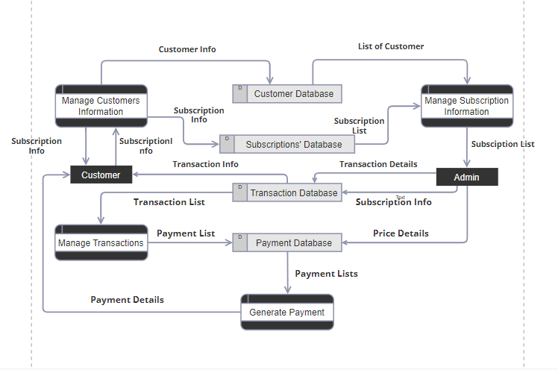FITHUB DATA FLOW DIAGRAM**3.5.2. ER DIAGRAM**

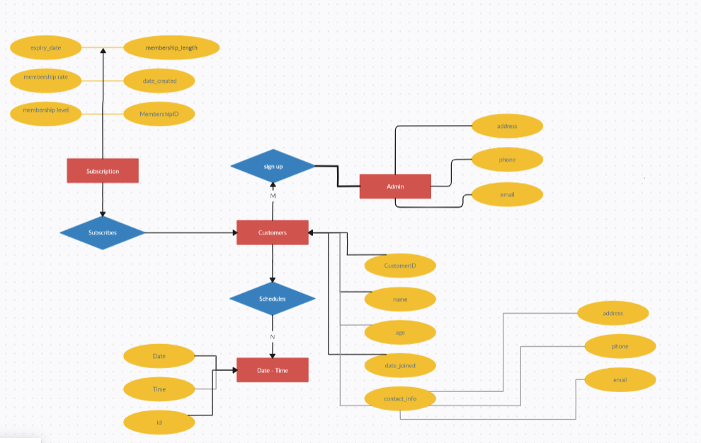

# CHAPTER 4 DEVELOPMENT ENVIRONMENT

The development environment plays a crucial role in the creation and deployment of any software project. In the case of Fithub, the online gym subscription management system, careful consideration has been given to selecting the appropriate tools and technologies to facilitate efficient development, testing, and deployment processes. This chapter provides an in-depth overview of the development environment used for building Fithub, including the integrated development environment (IDE), database management system, frontend framework, and backend technologies.

## 4.1 IDE and Framework

Visual Studio Code (VS Code) serves as the primary integrated development environment (IDE) for developing Fithub. VS Code is a lightweight, yet powerful code editor developed by Microsoft, renowned for its versatility, extensibility, and user-friendly interface. Fithub developers leverage VS Code's robust features, including syntax highlighting, code completion, and integrated terminal, to streamline the development workflow and enhance productivity. The built-in Git integration in VS Code facilitates version control and collaborative development, enabling seamless collaboration among team members. Additionally, VS Code's vast ecosystem of extensions allows developers to customize their environment with tools and plugins tailored to their specific needs, further enhancing the development experience.

## 4.2 Backend Infrastructure

* **Firebase Realtime Database:**

Firebase Realtime Database plays a pivotal role in Fithub's backend infrastructure, providing a cloud-hosted NoSQL database solution for storing and synchronizing data in real-time. With its scalable and flexible architecture, Firebase Realtime Database seamlessly integrates with frontend and backend applications, enabling Fithub to manage user data, subscription details, appointment schedules, and other essential information with ease. The real-time synchronization capabilities of Firebase ensure that changes made to the database are instantly propagated to all connected clients, delivering a responsive and interactive user experience.

* **Firebase Authentication:**

Firebase Authentication is instrumental in securing Fithub's backend services and protecting user data. Leveraging Firebase Authentication, Fithub implements robust user authentication and authorization mechanisms, ensuring that only authenticated users have access to sensitive features and data within the platform. With support for various authentication methods, including email/password, phone number, and third-party providers (e.g., Google, Facebook, Twitter), Firebase Authentication offers flexibility and convenience for users to securely log in and access their accounts on Fithub. Furthermore, Firebase Authentication seamlessly integrates with other Firebase services, such as Realtime Database, enabling seamless user authentication and data synchronization within the platform.

## 4.5 Development Workflow

The development workflow of Fithub is a structured process designed to ensure the efficient and effective creation, testing, and deployment of features and updates to the platform. This chapter provides an overview of the development workflow adopted for Fithub, outlining the key phases and activities involved in the software development lifecycle.

* **Planning Phase:**

The development workflow begins with the planning phase, where project stakeholders, including product managers, developers, and designers, collaborate to define project objectives, requirements, and milestones. During this phase, project goals are identified, and user stories are created to capture the desired functionality and features of the platform. Project timelines and resource allocations are established to guide the development process. Additionally, project management tools such as Trello, Asana, or Jira may be utilized to create project boards, organize tasks, and track progress throughout the development lifecycle.

* **Development Phase:**

Once the planning phase is complete, the development phase begins, where developers work on implementing the features and functionalities outlined in the project plan. Fithub developers utilize Visual Studio Code (VS Code) as the primary integrated development environment (IDE) for writing, debugging, and testing code. With its extensive set of features and extensions, VS Code enhances productivity and collaboration among developers, facilitating seamless code development and version control. Developers adhere to coding standards and best practices, ensuring code quality, readability, and maintainability throughout the development process.

* **Manual Testing Phase:**

The manual testing phase is a critical aspect of the development workflow, where the quality, functionality, and usability of the Fithub platform are validated through manual testing procedures. Fithub adopts a comprehensive manual testing strategy that includes various types of manual testing, such as exploratory testing, functional testing, and usability testing. Testers meticulously execute test cases and scenarios to verify the correctness and reliability of the platform's features and functionalities. Manual testing allows testers to simulate real-world user interactions and workflows, identifying and documenting any defects or issues encountered during testing.

* **Deployment Phase:**

The deployment phase involves the release and deployment of new features and updates to the production environment. Fithub follows a continuous integration and continuous deployment (CI/CD) approach to automate the build, test, and deployment processes. Code changes are automatically built, tested, and deployed to staging environments for validation and acceptance testing. Once validated, changes are promoted to the production environment, ensuring a seamless and efficient release process. Continuous monitoring and performance testing are conducted to detect and address any issues or regressions in the production environment, ensuring a reliable and high-performing user experience.

## 4.6. Coding

### [4.6.1]. index.html

<!DOCTYPE html>

<html lang="en">

<head>

<title>FitHub</title>

<meta charset="utf-8" />

<meta

name="viewport"

content="width=device-width, initial-scale=1, shrink-to-fit=no"

/>

<link

href="https://fonts.googleapis.com/css?family=Muli:300,400,700,900"

rel="stylesheet"

/>

<link rel="stylesheet" href="fonts/icomoon/style.css" />

<link rel="stylesheet" href="css/bootstrap.min.css" />

<link rel="stylesheet" href="css/jquery-ui.css" />

<link rel="stylesheet" href="css/owl.carousel.min.css" />

<link rel="stylesheet" href="css/owl.theme.default.min.css" />

<link rel="stylesheet" href="css/owl.theme.default.min.css" />

<link rel="stylesheet" href="css/jquery.fancybox.min.css" />

<link rel="stylesheet" href="css/bootstrap-datepicker.css" />

<link rel="stylesheet" href="fonts/flaticon/font/flaticon.css" />

<link rel="stylesheet" href="css/aos.css" />

<link

href="css/jquery.mb.YTPlayer.min.css"

media="all"

rel="stylesheet"

type="text/css"

/>

<!-- Remixicons-->

<link

rel="stylesheet"

href="https://cdnjs.cloudflare.com/ajax/libs/remixicon/4.1.0/remixicon.css"

/>

<link rel="stylesheet" href="css/style.css" />

</head>

<body data-spy="scroll" data-target=".site-navbar-target" data-offset="300">

<div class="site-wrap">

<div class="site-mobile-menu site-navbar-target">

<div class="site-mobile-menu-header">

<div class="site-mobile-menu-close mt-3">

<span class="icon-close2 js-menu-toggle"></span>

</div>

</div>

<div class="site-mobile-menu-body"></div>

</div>

<header

class="site-navbar py-4 js-sticky-header site-navbar-target"

role="banner"

>

<div class="container-fluid">

<div class="d-flex align-items-center">

<div class="site-logo"><a href="index.html">FitHub</a></div>

<div class="ml-auto">

<nav

class="site-navigation position-relative text-right"

role="navigation"

>

<ul

class="site-menu main-menu js-clone-nav mr-auto d-none d-lg-block"

>

<li><a href="#home-section" class="nav-link">Home</a></li>

<li>

<a href="#classes-section" class="nav-link">Classes</a>

</li>

<li>

<a href="#schedule-section" class="nav-link">Schedule</a>

</li>

<li>

<a href="#trainer-section" class="nav-link">Trainer</a>

</li>

<li>

<a href="#services-section" class="nav-link">Services</a>

</li>

</ul>

</nav>

</div>

<div class="ml-auto">

<nav

class="site-navigation position-relative text-right"

role="navigation"

>

<ul

class="site-menu main-menu site-menu-dark js-clone-nav mr-auto d-none d-lg-block"

>

<li class="cta">

<a href="./auth/login.html" class="nav-link"

><span class="rounded border border-primary"

>Join Us</span

></a

>

</li>

</ul>

</nav>

<a

href="#"

class="d-inline-block d-lg-none site-menu-toggle js-menu-toggle text-black float-right"

><span class="icon-menu h3"></span

></a>

</div>

</div>

</div>

</header>

<section class="section-hero">

<div class="container hero-box">

<div class="hero-content margin-bottom">

<h1 class="heading heading--1 margin-bottom">

A place for your fitness goals

</h1>

<p class="text-white">

We Offer Functional Training, Plyometric Boxes, Aerobics classes, TRX And Much More

</p>

</div>

<div class="btn-group">

<a href="./auth/login.html">

<button class="btn btn-success ml-2 mb-2 mt-2">

Join us

</button>

</a>

</div>

</div>

</section>

<div class="site-section section-1">

<div class="container">

<div class="row mb-5">

<div class="col-lg-3">

<div

class="counter d-flex align-items-start mb-5"

data-aos="fade-up"

data-aos-delay=""

>

<div class="icon-wrap">

<span class="flaticon-muscle text-primary"></span>

</div>

<div class="counter-text">

<strong>2</strong>

<span>Members</span>

</div>

</div>

</div>

<div class="col-lg-3">

<div

class="counter d-flex align-items-start mb-5"

data-aos="fade-up"

data-aos-delay="200"

>

<div class="icon-wrap">

<span class="flaticon-banana text-primary"></span>

</div>

<div class="counter-text">

<strong>10</strong>

<span>Health Program</span>

</div>

</div>

</div>

</div>

<div class="row">

<div class="col-lg-5 mr-auto mb-5 align-self-center">

<div class="mb-5">

<h2 class="section-title">Step Up Your Fitness</h2>

<p class="mb-5">

Welcome to FitHub Gym, where we are committed to helping you

step up your fitness game and achieve your goals like never

before. Our state-of-the-art facility and experienced trainers

are here to support you on your fitness journey and push you

to new heights of strength, endurance, and overall wellness.

</p>

<p>

<a

href="./auth/signup.html"

class="btn btn-primary smoothscroll py-3 px-4"

>Sing Up</a

>

</p>

</div>

</div>

<div class="col-lg-6">

<div class="image-absolute-box">

<img

src="images/about_1.jpg"

alt="Image"

class="img-fluid img-shadow"

/>

</div>

</div>

</div>

</div>

</div>

<div class="site-section section-2" id="classes-section">

<div class="container">

<div class="row">

<div class="col-lg-6 mb-5">

<h2 class="section-title">Classes</h2>

<p>

At FitHub Gym, we offer a wide variety of classes to cater to

all fitness levels and interests. Whether you are looking to

build strength, improve flexibility, or boost your cardio

endurance, our classes are designed to help you achieve your

fitness goals in a fun and supportive environment.

</p>

</div>

</div>

</div>

<div class="owl-carousel nonloop-block-13">

<a class="work-thumb" href="single-1.html">

<div class="work-text">

<h3>Aerobics</h3>

<span class="category">Fitness</span>

</div>

<img src="images/slide_0.jpg" alt="Image" class="img-fluid" />

</a>

<a class="work-thumb" href="single-2.html">

<div class="work-text">

<h3>Meditation</h3>

<span class="category">Mind and Body</span>

</div>

<img src="images/slide_1.jpg" alt="Image" class="img-fluid" />

</a>

<a class="work-thumb" href="single-3.html">

<div class="work-text">

<h3>Crossfit</h3>

<span class="category">Lose Weight</span>

</div>

<img src="images/slide_2.jpg" alt="Image" class="img-fluid" />

</a>

<a class="work-thumb" href="single-4.html">

<div class="work-text">

<h3>Weight Lifting</h3>

<span class="category">Cardio Vascular</span>

</div>

<img src="images/slide_3.jpg" alt="Image" class="img-fluid" />

</a>

<a class="work-thumb" href="single-5.html">

<div class="work-text">

<h3>Gym</h3>

<span class="category">Fitness</span>

</div>

<img src="images/slide_4.jpg" alt="Image" class="img-fluid" />

</a>

</div>

</div>

<div class="site-section section-2" id="schedule-section">

<div class="container">

<div class="row">

<div class="col-lg-6 mb-5">

<h2 class="section-title">Schedule</h2>

<p>

At FitHub Gym, we understand that life can be busy and finding

time to work out can be a challenge. That's why we offer a

convenient and flexible class schedule to accommodate your busy

lifestyle. Our goal is to make it easy for you to find the

perfect class at a time that works for you, so you can stay on

track with your fitness goals.

</p>

</div>

</div>

<div class="row">

<div class="col-12">

<ul

class="nav nav-tabs mb-5 border-bottom-0 justify-content-center tab-list-custom"

id="myTab"

role="tablist"

>

<li class="nav-item">

<a

class="nav-link active"

id="monday-tab"

data-toggle="tab"

href="#monday"

role="tab"

aria-controls="monday"

aria-selected="true"

>Monday</a

>

</li>

<li class="nav-item">

<a

class="nav-link"

id="tuesday-tab"

data-toggle="tab"

href="#tuesday"

role="tab"

aria-controls="tuesday"

aria-selected="false"

>Tuesday</a

>

</li>

<li class="nav-item">

<a

class="nav-link"

id="wednesday-tab"

data-toggle="tab"

href="#wednesday"

role="tab"

aria-controls="wednesday"

aria-selected="false"

>Wednesday</a

>

</li>

<li class="nav-item">

<a

class="nav-link"

id="wednesday-tab"

data-toggle="tab"

href="#wednesday"

role="tab"

aria-controls="wednesday"

aria-selected="false"

>Thursday</a

>

</li>

<li class="nav-item">

<a

class="nav-link"

id="wednesday-tab"

data-toggle="tab"

href="#wednesday"

role="tab"

aria-controls="wednesday"

aria-selected="false"

>Friday</a

>

</li>

<li class="nav-item">

<a

class="nav-link"

id="wednesday-tab"

data-toggle="tab"

href="#wednesday"

role="tab"

aria-controls="wednesday"

aria-selected="false"

>Sunday</a

>

</li>

</ul>

<div class="tab-content" id="myTabContent">

<div

class="tab-pane fade show active"

id="monday"

role="tabpanel"

aria-labelledby="monday-tab"

>

<table

class="table table-bordered table-custom table-striped"

>

<tbody>

<tr>

<td>Gym</td>

<td>8:00am - 10:00am</td>

<td>John Doe</td>

<td class="text-center">

<a href="./auth/login.html" class="smoothscroll"

>Join Now</a

>

</td>

</tr>

<tr>

<td>Meditation</td>

<td>10:00am - 10:30am</td>

<td>James Holmes</td>

<td class="text-center">

<a href="./auth/login.html" class="smoothscroll"

>Join Now</a

>

</td>

</tr>

<tr>

<td>Weight Lifting</td>

<td>1:00pm - 2:30pm</td>

<td>Ben Smith</td>

<td class="text-center">

<a href="./auth/login.html" class="smoothscroll"

>Join Now</a

>

</td>

</tr>

<tr>

<td>Crossfit</td>

<td>3:00pm - 3:45pm</td>

<td>Craig Peters</td>

<td class="text-center">

<a

style="color: #0a99e6"

href="./auth/login.html"

class="smoothscroll"

>Join Now</a

>

</td>

</tr>

<tr>

<td>Aerobics</td>

<td>5:00pm - 5:30pm</td>

<td>Paul Green</td>

<td class="text-center">

<a href="./auth/login.html" class="smoothscroll"

>Join Now</a

>

</td>

</tr>

</tbody>

</table>

</div>

<div

class="tab-pane fade"

id="tuesday"

role="tabpanel"

aria-labelledby="tuesday-tab"

>

<table

class="table table-bordered table-custom table-striped"

>

<tbody>

<tr>

<td>Gym</td>

<td>8:00am - 10:00am</td>

<td>John Doe</td>

<td class="text-center">

<a href="./auth/login.html" class="smoothscroll"

>Join Now</a

>

</td>

</tr>

<tr>

<td>Meditation</td>

<td>10:00am - 10:30am</td>

<td>James Holmes</td>

<td class="text-center">

<a href="./auth/login.html" class="smoothscroll"

>Join Now</a

>

</td>

</tr>

<tr>

<td>Weight Lifting</td>

<td>1:00pm - 2:30pm</td>

<td>Ben Smith</td>

<td class="text-center">

<a href="./auth/login.html" class="smoothscroll"

>Join Now</a

>

</td>

</tr>

<tr>

<td>Crossfit</td>

<td>3:00pm - 3:45pm</td>

<td>Craig Peters</td>

<td class="text-center">

<a href="./auth/login.html" class="smoothscroll"

>Join Now</a

>

</td>

</tr>

<tr>

<td>Aerobics</td>

<td>5:00pm - 5:30pm</td>

<td>Paul Green</td>

<td class="text-center">

<a href="./auth/login.html" class="smoothscroll"

>Join Now</a

>

</td>

</tr>

</tbody>

</table>

</div>

<div

class="tab-pane fade"

id="wednesday"

role="tabpanel"

aria-labelledby="wednesday-tab"

>

<table

class="table table-bordered table-custom table-striped"

>

<tbody>

<tr>

<td>Gym</td>

<td>8:00am - 10:00am</td>

<td>John Doe</td>

<td class="text-center">

<a href="./auth/login.html" class="smoothscroll"

>Join Now</a

>

</td>

</tr>

<tr>

<td>Meditation</td>

<td>10:00am - 10:30am</td>

<td>James Holmes</td>

<td class="text-center">

<a href="./auth/login.html" class="smoothscroll"

>Join Now</a

>

</td>

</tr>

<tr>

<td>Weight Lifting</td>

<td>1:00pm - 2:30pm</td>

<td>Ben Smith</td>

<td class="text-center">

<a href="./auth/login.html" class="smoothscroll"

>Join Now</a

>

</td>

</tr>

<tr>

<td>Crossfit</td>

<td>3:00pm - 3:45pm</td>

<td>Craig Peters</td>

<td class="text-center">

<a href="./auth/login.html" class="smoothscroll"

>Join Now</a

>

</td>

</tr>

<tr>

<td>Aerobics</td>

<td>5:00pm - 5:30pm</td>

<td>Paul Green</td>

<td class="text-center">

<a href="./auth/login.html" class="smoothscroll"

>Join Now</a

>

</td>

</tr>

</tbody>

</table>

</div>

<div

class="tab-pane fade"

id="thursday"

role="tabpanel"

aria-labelledby="thursday-tab"

>

<table

class="table table-bordered table-custom table-striped"

>

<tbody>

<tr>

<td>Gym</td>

<td>8:00am - 10:00am</td>

<td>John Doe</td>

<td class="text-center">

<a href="./auth/login.html" class="smoothscroll"

>Join Now</a

>

</td>

</tr>

<tr>

<td>Meditation</td>

<td>10:00am - 10:30am</td>

<td>James Holmes</td>

<td class="text-center">

<a href="./auth/login.html" class="smoothscroll"

>Join Now</a

>

</td>

</tr>

<tr>

<td>Weight Lifting</td>

<td>1:00pm - 2:30pm</td>

<td>Ben Smith</td>

<td class="text-center">

<a href="./auth/login.html" class="smoothscroll"

>Join Now</a

>

</td>

</tr>

<tr>

<td>Crossfit</td>

<td>3:00pm - 3:45pm</td>

<td>Craig Peters</td>

<td class="text-center">

<a href="./auth/login.html" class="smoothscroll"

>Join Now</a

>

</td>

</tr>

<tr>

<td>Aerobics</td>

<td>5:00pm - 5:30pm</td>

<td>Paul Green</td>

<td class="text-center">

<a href="./auth/login.html" class="smoothscroll"

>Join Now</a

>

</td>

</tr>

</tbody>

</table>

</div>

<div

class="tab-pane fade"

id="friday"

role="tabpanel"

aria-labelledby="friday-tab"

>

<table

class="table table-bordered table-custom table-striped"

>

<tbody>

<tr>

<td>Gym</td>

<td>8:00am - 10:00am</td>

<td>John Doe</td>

<td class="text-center">

<a href="./auth/login.html" class="smoothscroll"

>Join Now</a

>

</td>

</tr>

<tr>

<td>Meditation</td>

<td>10:00am - 10:30am</td>

<td>James Holmes</td>

<td class="text-center">

<a href="./auth/login.html" class="smoothscroll"

>Join Now</a

>

</td>

</tr>

<tr>

<td>Weight Lifting</td>

<td>1:00pm - 2:30pm</td>

<td>Ben Smith</td>

<td class="text-center">

<a href="./auth/login.html" class="smoothscroll"

>Join Now</a

>

</td>

</tr>

<tr>

<td>Crossfit</td>

<td>3:00pm - 3:45pm</td>

<td>Craig Peters</td>

<td class="text-center">

<a href="./auth/login.html" class="smoothscroll"

>Join Now</a

>

</td>

</tr>

<tr>

<td>Aerobics</td>

<td>5:00pm - 5:30pm</td>

<td>Paul Green</td>

<td class="text-center">

<a href="./auth/login.html" class="smoothscroll"

>Join Now</a

>

</td>

</tr>

</tbody>

</table>

</div>

<div

class="tab-pane fade"

id="sunday"

role="tabpanel"

aria-labelledby="sunday-tab"

>

<table

class="table table-bordered table-custom table-striped"

>

<tbody>

<tr>

<td>Gym</td>

<td>8:00am - 10:00am</td>

<td>John Doe</td>

<td class="text-center">

<a href="./auth/login.html" class="smoothscroll"

>Join Now</a

>

</td>

</tr>

<tr>

<td>Meditation</td>

<td>10:00am - 10:30am</td>

<td>James Holmes</td>

<td class="text-center">

<a href="./auth/login.html" class="smoothscroll"

>Join Now</a

>

</td>

</tr>

<tr>

<td>Weight Lifting</td>

<td>1:00pm - 2:30pm</td>

<td>Ben Smith</td>

<td class="text-center">

<a href="./auth/login.html" class="smoothscroll"

>Join Now</a

>

</td>

</tr>

<tr>

<td>Crossfit</td>

<td>3:00pm - 3:45pm</td>

<td>Craig Peters</td>

<td class="text-center">

<a href="./auth/login.html" class="smoothscroll"

>Join Now</a

>

</td>

</tr>

<tr>

<td>Aerobics</td>

<td>5:00pm - 5:30pm</td>

<td>Paul Green</td>

<td class="text-center">

<a href="./auth/login.html" class="smoothscroll"

>Join Now</a

>

</td>

</tr>

</tbody>

</table>

</div>

</div>

</div>

</div>

</div>

</div>

<div class="site-section" id="trainer-section">

<div class="container">

<div class="row">

<div class="col-lg-6 mb-5">

<h2 class="section-title">Trainers</h2>

<p>

At FitHub Gym, we are proud to have a team of experienced and

dedicated fitness trainers who are committed to helping you

reach your health and wellness goals. Our trainers bring a

wealth of knowledge, expertise, and passion to every session,

creating a supportive and motivating environment to help you

achieve your best results.

</p>

</div>

</div>

<div class="row large-gutters">

<div class="col-md-6 person col-lg-4 mb-4 mb-lg-0">

<img

src="images/person_1.jpg"

alt="Image"

class="img-fluid mb-5"

/>

<h3 class="name-style">James Holmes</h3>

<p class="mb-4 opacity-7">Weight Lifting Trainer</p>

<p>

Our Weight Lifting Trainer, James Holmes , brings a wealth of

knowledge and expertise in weight lifting techniques, strength

training, and muscle building. With 5 years of experience in the

fitness industry,

</p>

</div>

<div class="col-md-6 person col-lg-4 mb-4 mb-lg-0 mt-5">

<img

src="images/person_2.jpg"

alt="Image"

class="img-fluid mb-5"

/>

<h3 class="name-style">Kelly Green</h3>

<p class="mb-4 opacity-7">Aerobatics Trainer</p>

<p>

Our Aerobatics Trainer, Kelly Green, is a certified aerial

acrobatics instructor with 4.5 years of experience in the field.

With a background in gymnastics, dance, and circus arts, Kelly

Green brings a unique blend of skills and expertise to help you

master the art of aerial acrobatics in a fun and engaging way

</p>

</div>

<div class="col-md-6 person col-lg-4 mb-4 mb-lg-0">

<img

src="images/person_3.jpg"

alt="Image"

class="img-fluid mb-5"

/>

<h3 class="name-style">Ben Smith</h3>

<p class="mb-4 opacity-7">Meditation Trainer</p>

<p>

Our Meditation Trainer, Ben Smith, is a certified meditation

instructor with 6 years of experience in leading meditation

sessions and mindfulness practices. With a background in yoga,

mindfulness, and holistic wellness.

</p>

</div>

</div>

</div>

</div>

<div class="site-section" id="services-section">

<div class="container">

<div class="row">

<div class="col-lg-6 mb-5">

<h2 class="section-title">Our Featured Services</h2>

<p>

At FitHub Gym, we are dedicated to providing our members with a

top-notch fitness experience that goes beyond just a workout.

Our Features Section highlights the unique amenities, services,

and programs that set us apart and make your fitness journey

enjoyable, effective, and rewarding

</p>

</div>

</div>

</div>

<div class="container">

<div class="owl-carousel nonloop-block-14">

<div class="service">

<div>

<span

class="flaticon-muscle display-3 text-white mb-4 d-inline-block"

></span>

<h3>Weight Lifting</h3>

<span></span>

<p>

Our gym is equipped with top-of-the-line weight lifting

equipment to help you build muscle, increase strength,and

sculpt your body.Our experienced trainers can guide you

through proper lifting techni

</p>

</div>

</div>

<div class="service">

<div>

<span

class="flaticon-stationary-bike display-3 text-white mb-4 d-inline-block"

></span>

<h3>Meditation</h3>

<p>

Find peace in our meditation classes that focus on

mindfulness, relaxation, and stress relief. Learn how to quiet

the mind, improve mental clarity through guided meditation

sessions .

</p>

</div>

</div>

<div class="service">

<div>

<span

class="flaticon-banana display-3 text-white mb-4 d-inline-block"

></span>

<h3>Crossfit</h3>

<p>

Challenge yourself with our Crossfit classes that combine

high-intensity interval training, functional movements, and

strength exercises to improve endurance, agility, and overall

fitness.

</p>

</div>

</div>

<div class="service">

<div>

<span

class="flaticon-heart display-3 text-white mb-4 d-inline-block"

></span>

<h3>Aerobics</h3>

<p>

Get your heart pumping and calories burning in our high-energy

aerobics classes that combine cardio exercises with

dance-inspired movements and having fun while improving your

cardiovascular fitness.

</p>

</div>

</div>

<div class="service">

<div>

<span

class="flaticon-scale display-3 text-white mb-4 d-inline-block"

></span>

<h3>Gym</h3>

<p>

Our gym features a variety of fitness equipment, including

cardio machines, strength training equipment, and functional

training areas to cater to all your workout needs. joining

group fitness classes

</p>

</div>

</div>

<div class="service">

<div>

<span

class="flaticon-weight display-3 text-white mb-4 d-inline-block"

></span>

<h3>Circling</h3>

<p>

Experience the power of connection and community in our

circling sessions, where participants come together in a safe

and supportive space to share authentic conversation and

meaningful connections.

</p>

</div>

</div>

</div>

</div>

</div>

<div class="site-section bg-dark" id="contact-section">

<div class="container">

<div class="row justify-content-center">

<div class="col-md-7">

<h2 class="mb-3 text-title">Contact Us</h2>

<p class="mb-5">

We are dedicated to helping you achieve your fitness goals and

are here to assist you with any questions or inquiries you may

have.please fill out the contact form below and we will get back

to you as soon as possible.

</p>

<form method="post" data-aos="fade">

<div class="form-group row">

<div class="col-md-6 mb-3 mb-lg-0">

<input

type="text"

class="form-control"

placeholder="First name"

/>

</div>

<div class="col-md-6">

<input

type="text"

class="form-control"

placeholder="Last name"

/>

</div>

</div>

<div class="form-group row">

<div class="col-md-12">

<input

type="text"

class="form-control"

placeholder="Subject"

/>

</div>

</div>

<div class="form-group row">

<div class="col-md-12">

<input

type="email"

class="form-control"

placeholder="Email"

/>

</div>

</div>

<div class="form-group row">

<div class="col-md-12">

<textarea

class="form-control"

id=""

cols="30"

rows="10"

placeholder="Write your message here."

></textarea>

</div>

</div>

<div class="form-group row">

<div class="col-md-6">

<input

type="submit"

class="btn btn-primary py-3 px-5 btn-block"

value="Send Message"

/>

</div>

</div>

</form>

</div>

</div>

</div>

</div>

<footer class="footer-section">

<div class="container">

<div class="row">

<div class="col-md-4">

<h3>About FitHub</h3>

<p>

Welcome to FitHub Gym, where we are dedicated to helping you

elevate your fitness to the next level. Our Peak Performance

Training program is designed to push you beyond your limits and

help you achieve your fitness goals faster than ever before.

</p>

<div class="share">

<a href="#" class="fab fa-facebook-f"></a>

<a href="#" class="fab fa-twitter"></a>

<a href="#" class="fab fa-instagram"></a>

<a href="#" class="fab fa-linkedin"></a>

<a href="#" class="fab fa-youtube"></a>

</div>

</div>

<div class="col-md-3 ml-auto">

<h3>Links</h3>

<ul class="list-unstyled footer-links">

<li><a href="index.html#home-section">Home</a></li>

<li><a href="index.html#classes-section">Classes</a></li>

<li><a href="index.html#schedule-section">Schedule</a></li>

<li><a href="index.html#trainer-section">Trainer</a></li>

<li><a href="index.html#services-section">Services</a></li>

</ul>

</div>

<div class="col-md-4">

<h3>Subscribe</h3>

<p>

Elevate your fitness at FitHub Gym - where peak performance is

within reach.

</p>

<form action="#">

<div class="d-flex mb-5">

<input

type="text"

class="form-control rounded-0"

placeholder="Email"

/>

<input

type="submit"

class="btn btn-primary rounded-0"

value="Subscribe"

/>

</div>

</form>

</div>

</div>

<div class="row pt-5 mt-5 text-center">

<div class="col-md-12">

<div class="pt-5">

<p>

<!-- Link back to Colorlib can't be removed. Template is licensed under CC BY 3.0. -->

Copyright &copy;

<script>

document.write(new Date().getFullYear());

</script>

<!-- Link back to Colorlib can't be removed. Template is licensed under CC BY 3.0. -->

</p>

</div>

</div>

</div>

</div>

</footer>

</div>

<!-- .site-wrap -->

<script src="js/jquery-3.3.1.min.js"></script>

<script src="js/jquery-migrate-3.0.1.min.js"></script>

<script src="js/jquery-ui.js"></script>

<script src="js/popper.min.js"></script>

<script src="js/bootstrap.min.js"></script>

<script src="js/owl.carousel.min.js"></script>

<script src="js/jquery.stellar.min.js"></script>

<script src="js/jquery.countdown.min.js"></script>

<script src="js/bootstrap-datepicker.min.js"></script>

<script src="js/jquery.easing.1.3.js"></script>

<script src="js/aos.js"></script>

<script src="js/jquery.fancybox.min.js"></script>

<script src="js/jquery.sticky.js"></script>

<script src="js/jquery.mb.YTPlayer.min.js"></script>

<script src="js/main.js"></script>

</body>

</html>

### [4.6.2]. login.html

<!DOCTYPE html>

<html lang="en">

<head>

<meta charset="UTF-8">

<meta name="viewport" content="width=device-width, initial-scale=1.0">

<title>Login Page</title>

<link rel="preconnect" href="https://fonts.gstatic.com">

<link rel="stylesheet" type="text/css" href="./auth/loading.css">

<!-- Bootstrap CSS -->

<link href="https://cdn.jsdelivr.net/npm/bootstrap@5.3.0-alpha1/dist/css/bootstrap.min.css" rel="stylesheet">

<style>

body {

background-color: #f4f4f4;

}

.login-form {

max-width: 400px;

margin: 100px auto;

padding: 30px;

background-color: #fff;

border-radius: 10px;

box-shadow: 0px 0px 10px rgba(0,0,0,0.1);

}

.hidden {

display: none;

}

</style>

</head>

<body>

<div class="container">

<div class="login-form">

<h2 class="text-center mb-4">Login</h2>

<form id="loginForm">

<div class="mb-3">

<label for="email" class="form-label">Email</label>

<input type="email" class="form-control" id="email" required>

</div>

<div class="mb-3">

<label for="password" class="form-label">Password</label>

<input type="password" class="form-control" id="password" required>

</div>

<div class="mb-3">

<label for="loginType" class="form-label">Login Type</label>

<select class="form-select" id="loginType" required>

<option value="admin">Admin</option>

<option value="user">User</option>

</select>

</div>

<div class="row align-items-center justify-content-center">

<button type="button" class="btn btn-success col-auto" id="loginBtn2" onclick="login()">Login</button>

</div>

<small class="row form-text text-primary d-flex text-center ">

<a href="./signup.html" class="text-reset text-decoration-none">Don't have an account? SIGN UP</a>

</small>

<small id="incorrectCredentials" class="form-text text-danger hidden">Incorrect credentials.</small>

<small id="notAdmin" class="form-text text-danger hidden">You are not a valid admin, try user</small>

</form>

</div>

</div>

<div id="loadingOverlay">

<div class="loadingContainer">

<div class="loadingSpinner"></div>

<div class="loadingText">Please wait...</div>

</div>

</div>

<!-- Bootstrap JS (optional) -->

<!-- <script src="https://cdn.jsdelivr.net/npm/bootstrap@5.3.0-alpha1/dist/js/bootstrap.bundle.min.js"></script> -->

<!-- The core Firebase JS SDK is always required and must be listed first -->

</body>

<script src="https://www.gstatic.com/firebasejs/8.6.8/firebase-app.js"></script>

<script src="https://www.gstatic.com/firebasejs/8.6.8/firebase-auth.js"></script>

<script src="https://www.gstatic.com/firebasejs/8.6.8/firebase-database.js"></script>

<!-- Our script must be loaded after firebase references -->

<script src="./auth/index.js"></script>

</html>

# CHAPTER 5 TESTING

Software testing is the process which checks for errors and gaps and finds out whether the application meets the desired expectations or not before the application is installed and goes live.

Testing is important because of the following reasons :-

* **Identifies defects early**- It identifies issues and defects with the written code so that they can be fixed before the software is delivered.
* **Increases customer trust and satisfaction** -Testing a product through its development cycle builds customer trust and satisfaction as it identifies the strong and weak points of the application.
* **Saves Money**- The issues that go unnoticed due to lack of software testing can cause bigger price tags for the organization. It can be more expensive and complicated to resolve the issue after the application launches.
* **Helps with scalability**- It is done to find out how well an application scales with increasing workloads such as data volume, user traffic, etc.
* **Bug-free application**- The main task of software testing is to identify bugs and inform the concerned developing team about it. After fixing the bug, the team again rechecks the bug for its status.
* **Speed up development process-** Software testing helps the development team speed up the development process by detecting defects.

**Unit Testing:**

Unit testing involves the design of test cases that validate that the internal program logic is functioning properly and that program inputs produce valid outputs. All decision branches and internal code flow should be validated. It is the testing of individual software units of the application.it is done after the completion of an individual unit before integration.

**Functional testing:**

Functional tests provide systematic demonstrations that functions tested are available as specified by the business and technical requirements, system documentation, and user manuals. It ensures all the features are working as expected like searching for routes, booking tickets, etc.

**System Test**

System testing ensures that the entire integrated software system meets requirements. It tests a configuration to ensure known and predictable results. An example of system testing is the configuration-oriented system integration test. System testing is based on process descriptions and flows, emphasizing pre-driven process links and integration points.

**White Box Testing**

White Box Testing is a testing in which the software tester knows the inner workings, structure and language of the software or at least its purpose. It is purpose. It is used to test areas that cannot be reached from a black box level.

**Black Box Testing**

Black Box Testing is testing the software without any knowledge of the inner workings, structure or language of the module being tested. Black box tests, like most other kinds of tests, must be written from a definitive source document, such as specification or requirements document, such as specification or requirements document. It is a testing in which the software under test is treated, as a black box You cannot “see” into it. The test provides inputs and responds to outputs without considering how the software works.

**Unit Testing:**

Unit testing is usually conducted as part of a combined code and unit test phase of the software lifecycle, although it is not uncommon for coding and unit testing to be conducted as two distinct phases.

**Performance Testing**:

It includes verifying the system’s responsiveness and load times during peak periods.

**Security Testing**:

Testing for vulnerabilities such as unauthorized access and payment security.

**Localization Testing**:

Testing the system’s adaptability to different languages, regional preferences, etc.

**Regression Testing**:

Checking previously fixed issues so that they don’t reoccur after new upgrades.

**Usability Testing**:

It includes assessing the system’s user-friendliness including ease of navigation, clarity of instructions, etc.

**Compatibility Testing**:

It ensures that the system works across different devices like desktops, laptops, phones and web browsers.

**Accessibility Testing**:

Check if the system is accessible to users with disabilities and how well the system fits with the guidelines.

# CHAPTER 6 OUTPUT SCENES

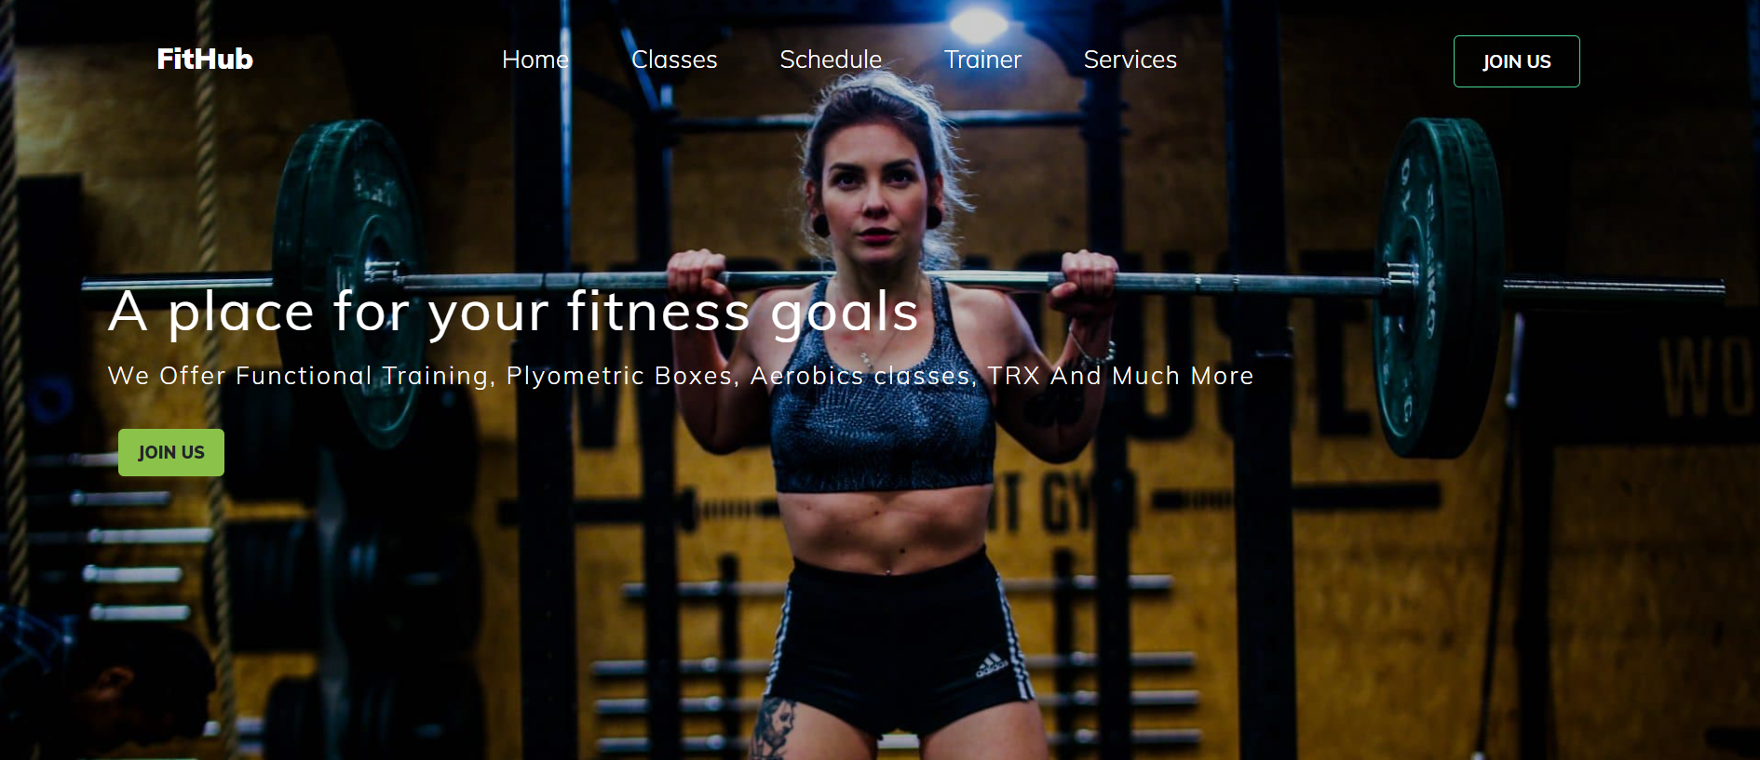

**Home Page**

The homepage of Fithub serves as the central hub for users to navigate through the platform's offerings. Users can easily explore the variety of services provided by Fithub, gaining an overview of available subscription plans and gym facilities. Additionally, the homepage provides intuitive options for users to join the platform by signing up for a new account or logging in if they are already registered members, ensuring a seamless onboarding experience.

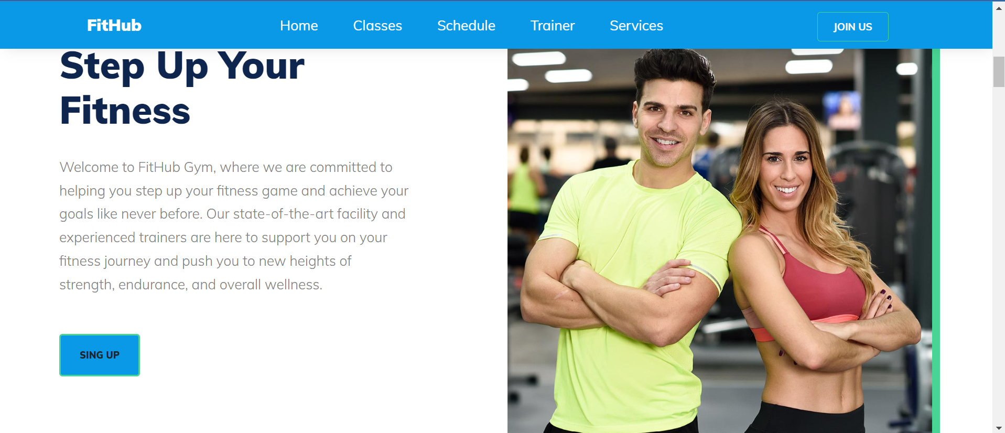

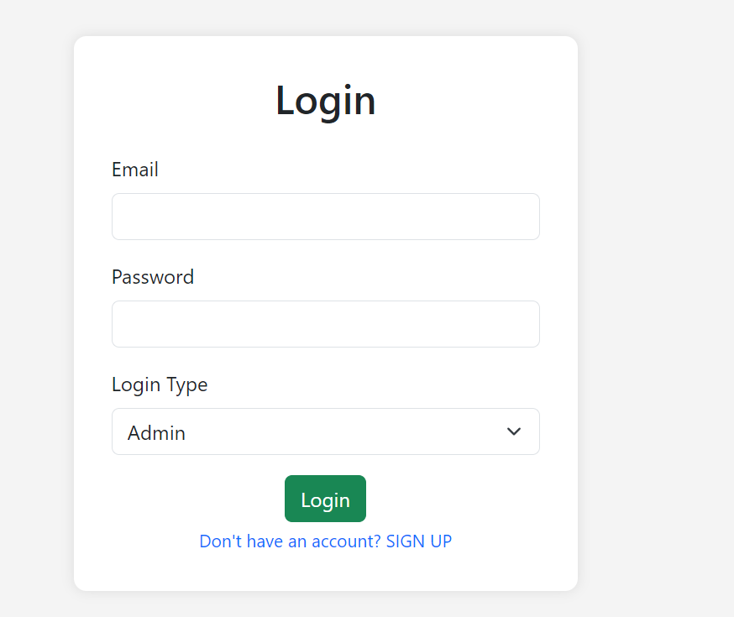

**Login Page**

The login page of Fithub offers a straightforward interface where users can enter their email, password, and select their user type (admin or user). For new users, a direct link to the sign-up page is provided, facilitating easy registration. This streamlined design ensures both security and accessibility for users accessing the platform.

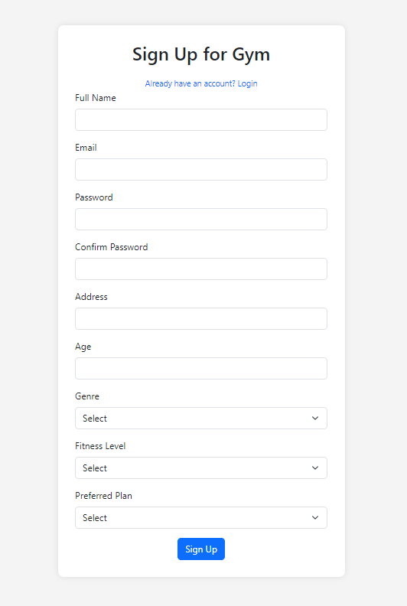

**Sign Up Page**

The sign-up page for Fithub provides a seamless process for users to register for gym membership. Users can conveniently input their full name, email, password, and address, along with additional details such as age, gender, and fitness level to tailor their experience. Furthermore, users are prompted to select their preferred plan, ensuring a personalized journey through Fithub's offerings.

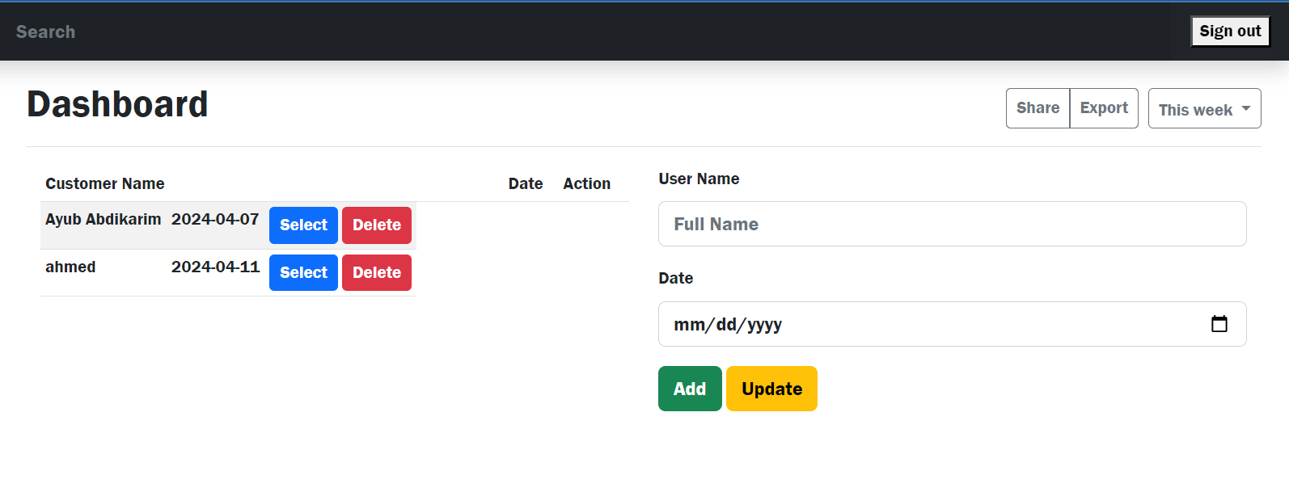

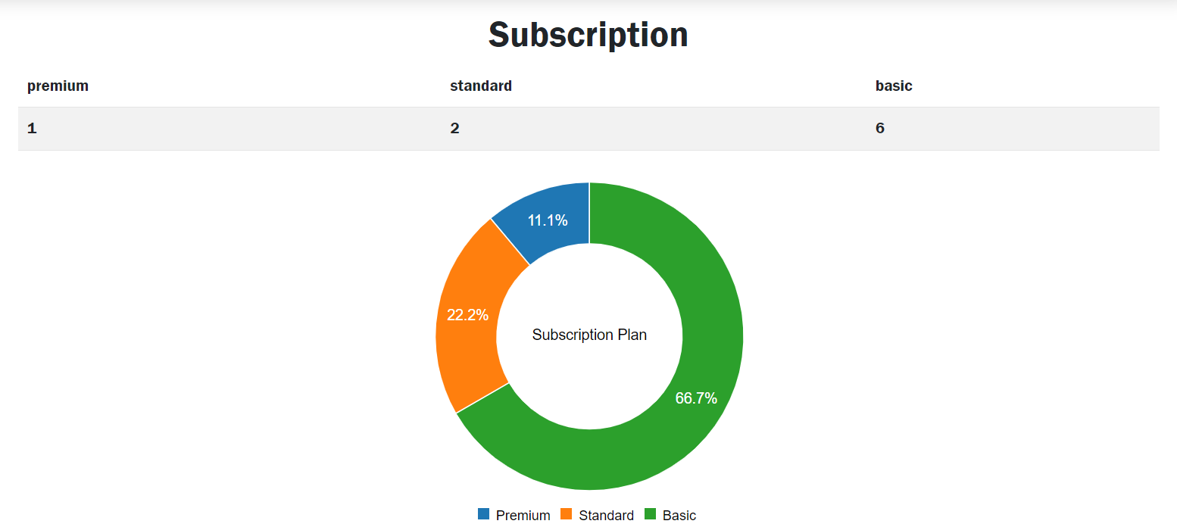

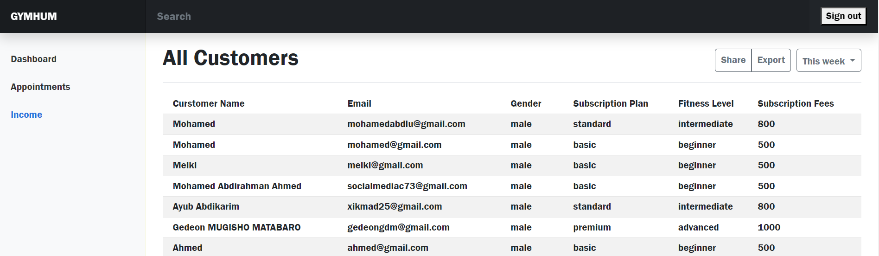

# CHAPTER 7 CONCLUSION

In the dynamic landscape of fitness management, Fithub emerges as a beacon of innovation and efficiency. Throughout this report, we have delved into the intricate details of the development process, elucidating the multifaceted components that culminate in the creation of this comprehensive online gym subscription management system.

Fithub epitomizes a convergence of cutting-edge technologies and user-centric design principles. From its intuitive user interface to its robust backend infrastructure, every aspect of Fithub is meticulously crafted to enhance user experience and streamline gym subscription management. By leveraging HTML, CSS, JavaScript, Firebase, and Bootstrap, Fithub empowers users with seamless navigation, secure authentication, and real-time data management, ensuring a smooth and intuitive experience from signup to subscription.

Moreover, Fithub embodies a commitment to continuous improvement and adaptability. Through manual testing procedures and rigorous quality assurance measures, we ensure that Fithub meets the highest standards of reliability, security, and performance. Our iterative development approach allows for flexibility and scalability, enabling us to adapt to evolving user needs and technological advancements.

As we conclude this report, it is evident that Fithub represents more than just a software solution; it embodies a vision of empowerment and convenience in the realm of fitness management. With a steadfast dedication to excellence and innovation, Fithub stands poised to revolutionize the way individuals engage with fitness services, fostering a healthier and more connected community.

In the ever-evolving landscape of technology and fitness, Fithub remains steadfast in its commitment to excellence, innovation, and user satisfaction. As we look towards the future, we are excited to continue pushing the boundaries of what is possible, and to empower individuals worldwide to pursue their fitness goals with confidence and convenience.

# CHAPTER 8 FUTURE SCOPE OF THE PROJECT

Looking ahead, Fithub, born as a school project, holds exciting potential to step into the real world, opening up avenues for growth and expansion within the fitness industry.

In the future, Fithub sees itself smoothly transitioning from the classroom to real-life application. It plans to amp up user satisfaction by giving personalized workout recommendations and tailored plans, thanks to digging into advanced analytics and user data.

Moreover, Fithub dreams of becoming more than just a gym subscription platform. It wants to team up with other fitness brands to offer users a whole package of resources, from workout guides to nutrition tips, making fitness more accessible and enjoyable for everyone.

Also, Fithub is eyeing up cool tech like virtual reality and augmented reality to take user experience to the next level. Imagine putting on a VR headset and being transported to a virtual gym where you can work out with friends or take on fitness challenges—it's all in Fithub's future plans.

And let's not forget about reaching out to more people globally. Fithub wants to speak everyone's language by offering support in multiple languages and tailoring its services to fit different cultures and preferences, making sure no one feels left out.

# CHAPTER 9 REFERENCES

Brown. e. (2020). Enhancing User Experience in Fitness Management System: A Comparative Analysis.

*Boot Strap 5*. (2023, 11 21). Retrieved from https://getbootstrap.com/: https://getbootstrap.com/docs/5.0/getting-started/introduction/

Duckett, J. (2011). *HTML & CSS: Design and Build Web Sites.* Wiley.

Duckett, J. (2013). *JavaScript and jQuery: Interactive Front-End Web Development.* Wiley.

*Fire Base*. (2024). Retrieved from Documentation: https://firebase.google.com/docs

John, N., & Smith. (2019). Technology Adoption in the Fitness Industry: A Review of Current Trends.

Patel, & Gupta. (2018). Cloud-Based Solution for Gymm Mnangement: Opportunities and Challenges.